SE16N- Data Browser

SE16/SE16N: Data Browser is a tool to check data in the database tables. Here are few examples how to work with SE16N

**Transaction Code: SE16N**

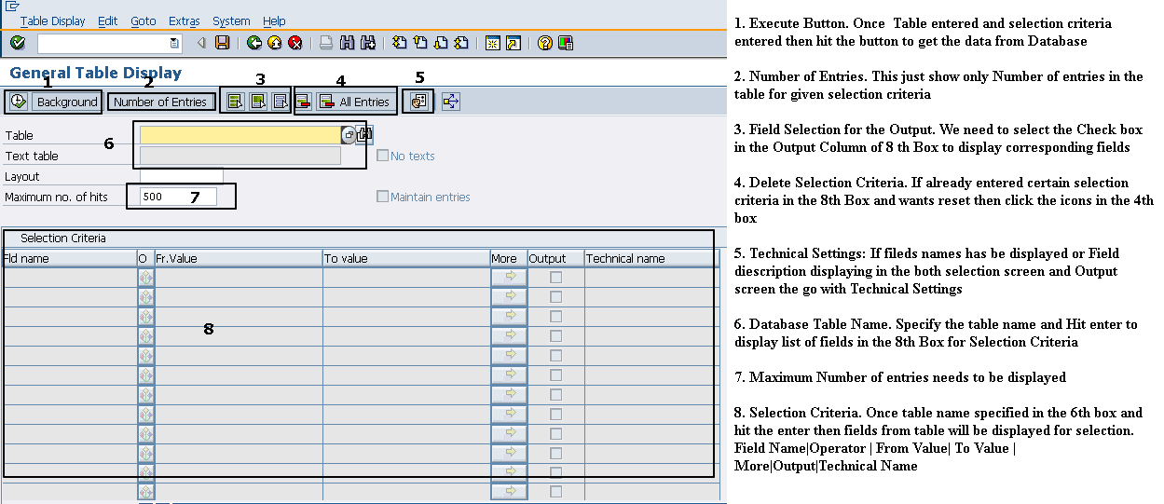

**Display List Of Sales Orders for the Given Customer**

Step1: Run the Transaction: SE16N

Step2: Enter Table Name: VBAK

Step3: Find the Customer Fields (KUNNR) By clicking the Find Button on the Standard Toolbar

Step4: Enter the Customer Number

Step5: Click on Execute

**Step1: Run SE16N Transaction**



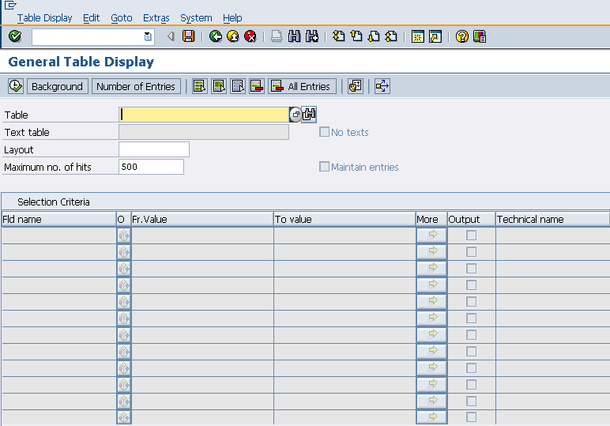

**Step2: Enter Table Name: VBAK and Hit Enter**

Fields from the VBAK table will be appeared in the Selection Criteria Section

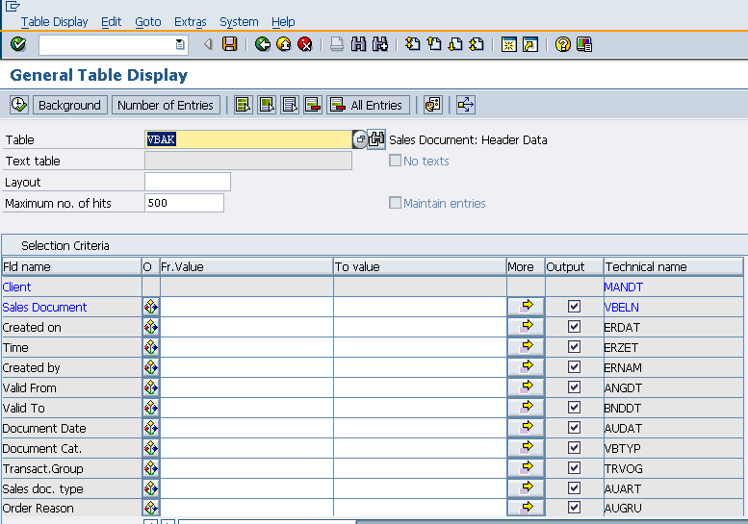

**Step3: Find the Customer Number by clicking the Find Button**

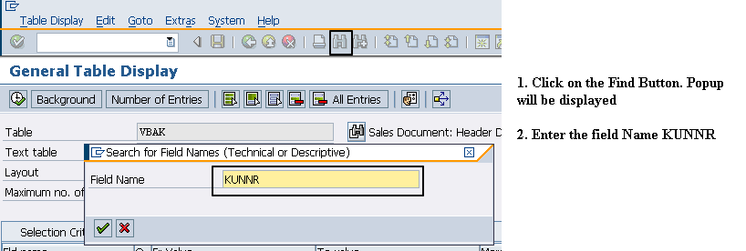

**Step4: Enter the Customer Number**

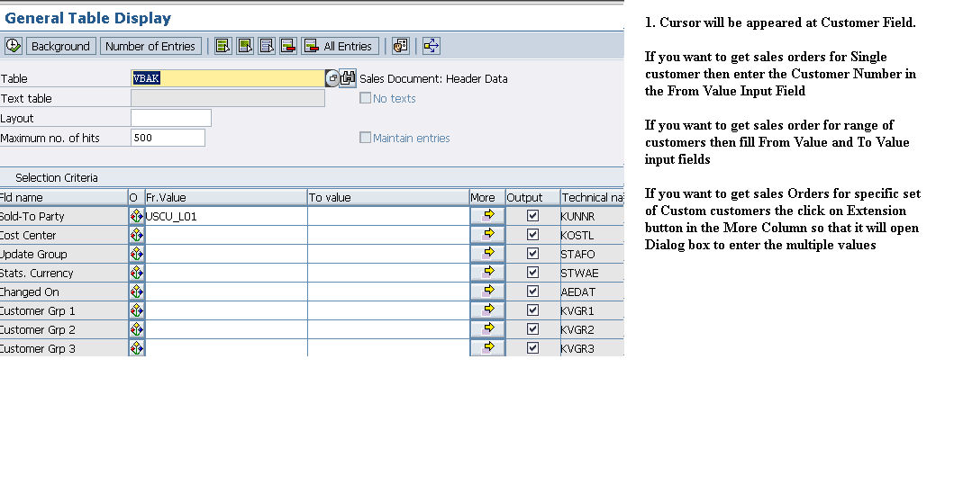

**Step5: Execute. Click on Execute Button**

